**DECIMAL TO HEXADECIMAL CONVERSION**  
  
  
**EXP NO: 27**  
  
  
  
  
  
**AIM:**To write a C program to implement decimal  
to hexadecimal conversion.  
  
  
  
  
  
**ALGORITHM:**  
  
  
1)      Store  
the remainder when the number is divided by 8 in an array.  
  
  
2)      Divide  
the number by 8 now  
  
  
3)      Repeat  
the above two steps until the number is not equal to 0.  
  
  
4)      Print  
the array in reverse order now.

**PROGRAM:**

#include<stdio.h>

int main(){

int decimal;

int i=1,j,temp;

char hexa[100];

printf("Enter any postive number:");

scanf("%d",&decimal);

while(decimal!=0){

temp=decimal%16;

if (temp < 10)

temp = temp + 48;

else

temp = temp + 55;

hexa[i++] = temp;

decimal = decimal/ 16;

}

printf("Hexadecimal value is: ");

for (j = i - 1; j > 0; j--)

printf("%c", hexa[j]);

return 0;

}

**INPUT & OUTPUT:**

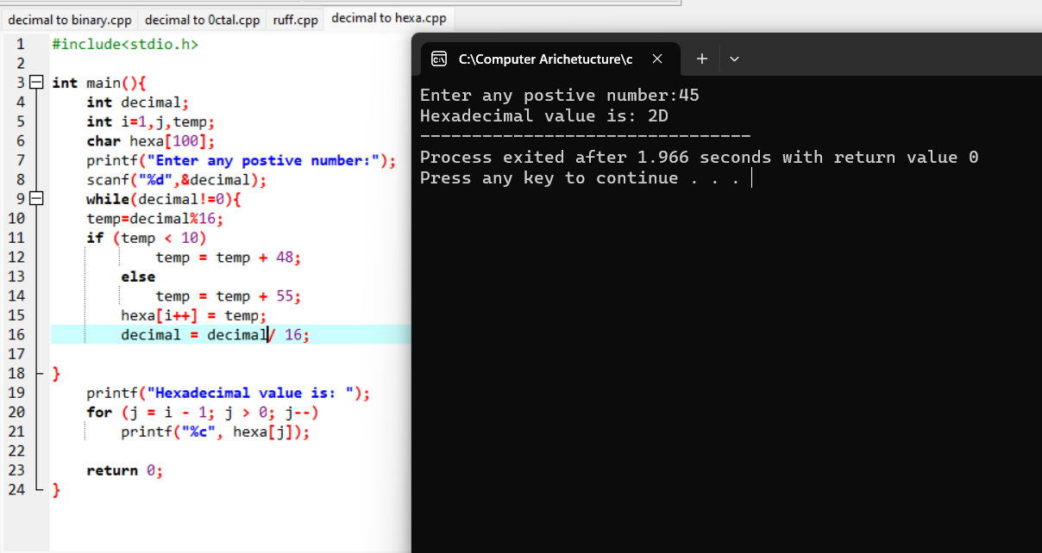

**RESULT:**

Thus in this way we can write C program for Decimal to Hexadecimal convertion.